**COAL LAB 6**

21k-4834

**TASK 1**

include irvine32.inc

.data

prompt byte "Generating 20 random numbers between 0 and 990",0

.code

main proc

mov eax, (black + (blue*16))

call settextcolor

mov edx, offset prompt

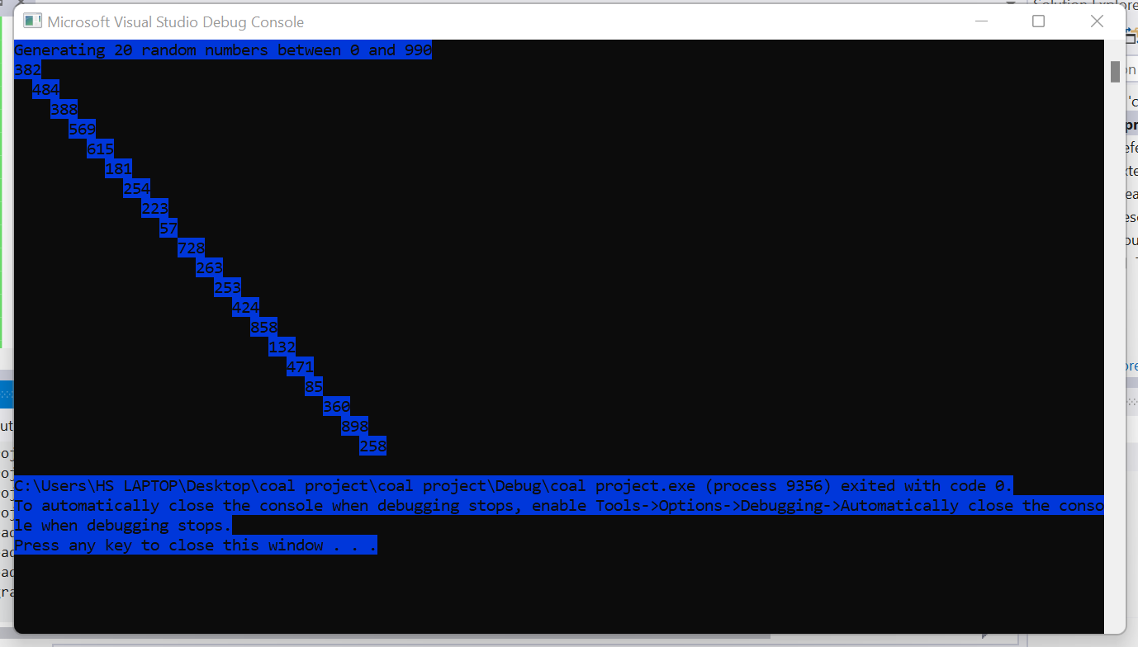

call writestring

call crlf

call randomize

mov ecx, 20

mov dl, 0

mov dh,1

call gotoxy

l1:

mov eax, 5

call delay

mov eax, 990

call randomrange

call writedec

inc dh

add dl, 2

call gotoxy

loop l1

exit

main endp

end main

**TASK 2**

include irvine32.inc

.data

var dword ?

.code

main proc

call randomize

mov ecx, 100

l1:

call GetMaxXY ; dx = col, ax = row

mov bx, ax

movzx eax, dx

call randomrange

mov var, eax

mov dl, byte ptr var

movzx eax, bx

call randomrange

mov var, eax

mov dh, byte ptr var

call Gotoxy ; dh = row, dl = col

mov eax, 100

call delay

mov eax, 'a'

call writechar

loop l1

exit

main endp

end main

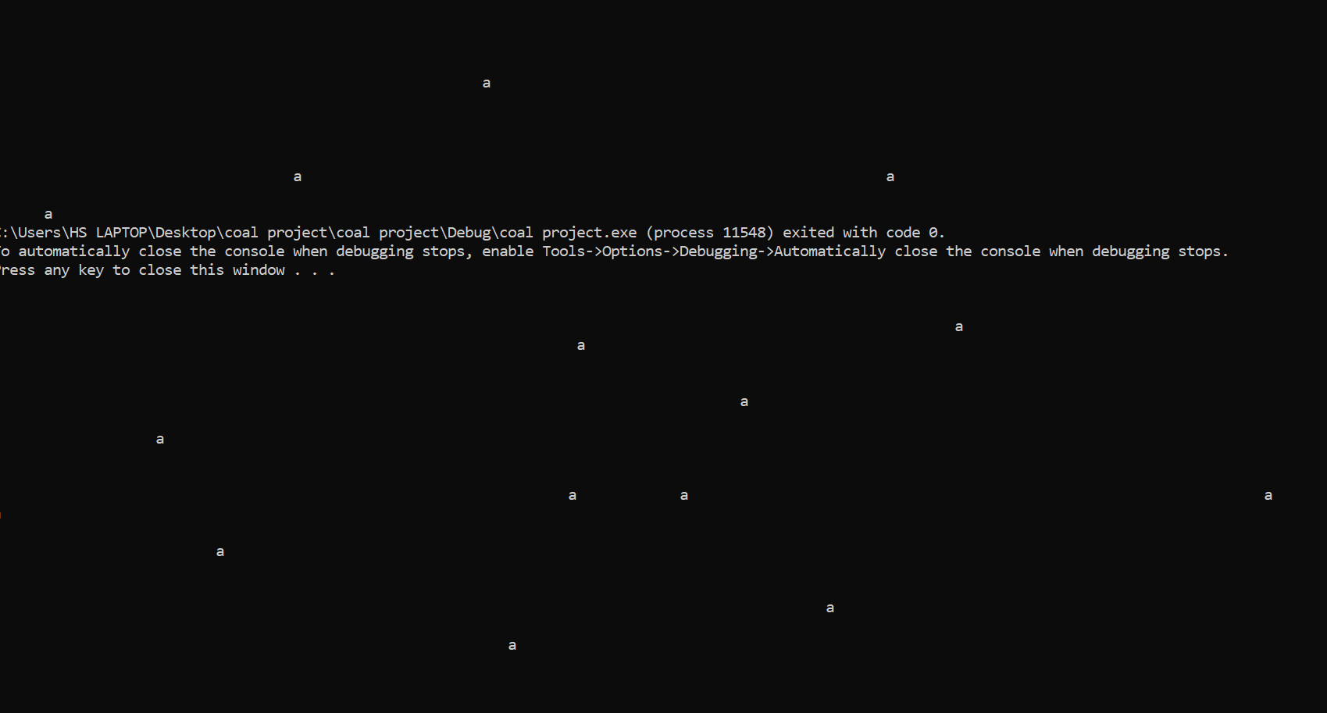

**TASK 3**

include irvine32.inc

.code

main proc

call randomize

mov ecx, 10

l1:

mov eax, 4294967294

call randomrange

call writedec

call crlf

loop l1

call crlf

mov ecx, 10

l2:

mov eax, 100

call randomrange

sub eax, 50

call writeint

call crlf

loop l2

exit

main endp

end main

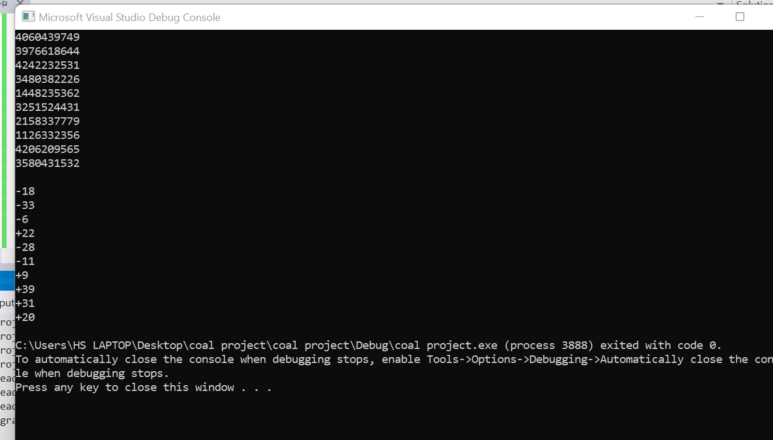

**TASK 4**

include irvine32.inc

.data

buffer byte 101 dup(?)

filename byte "MyFile.txt",0

fileHandle handle ?

stringLength dword ?

bytesWritten dword ?

prompt1 byte "Enter upto 100 chars : ",0

prompt2 byte "Bytes written : ",0

.code

main proc

;creating file

mov edx, offset filename

call createoutputfile

mov filehandle, eax

;reading string

mov edx, offset prompt1

call writestring

mov ecx, 101

mov edx, offset buffer

call readstring

mov stringlength, eax

;writing file

mov eax, filehandle

mov edx, offset buffer

mov ecx, stringlength

call writetofile

mov byteswritten, eax

mov edx, offset prompt2

call writestring

mov eax, byteswritten

call writedec

call crlf

;closing file

call closefile

exit

main endp

end main

